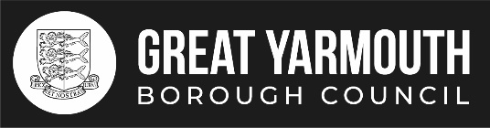
NOTICE OF REFERENDUM

Referendum on the adoption of the Belton with Browston, Burgh Castle and Fritton with St Olaves Neighbourhood Plan

- A referendum will be held on Thursday, 27 March 2025 to decide on the Question below:

‘Do you want Great Yarmouth Borough Council and the Broads Authority to use the Neighbourhood Plan for Belton with Browston, Burgh Castle and Fritton with St Olaves to help them decide planning applications in the neighbourhood area?’

- Applications to be included on the register of electors for this referendum must be received no later than Tuesday, 11 March 2025. Applications can be made online www.gov.uk/register-to-vote

- New applications for, or amendments or cancellations of postal votes and amendments or cancellations of existing proxy votes must reach the Electoral Registration Officer at Town Hall, Great Yarmouth NR30 2QF by 5 pm on Wednesday, 12 March 2025. Applications can be made online www.gov.uk/apply-postal-vote

- Applications for a Voter Authority Certificate or an Anonymous Elector’s Document valid for this referendum must reach the Electoral Registration Officer by 5 pm on Wednesday, 19 March 2025. Applications for a Voter Authority Certificate can be made online: www.gov.uk/apply-for-photo-id-voter-authority-certificate.

- New applications to vote by proxy at this referendum must reach the Electoral Registration Officer at Town Hall, Great Yarmouth NR30 2QF by 5 pm on Wednesday, 19 March 2025. Applications can be made online www.gov.uk/apply-proxy-vote

- Applications to vote by proxy at this referendum applied for on grounds of physical incapacity, because of works reasons, or your photo ID is lost, stolen, destroyed or damaged that occurred after 5 pm on Wednesday, 19 March 2025, must reach the Electoral Registration Officer at Town Hall, Great Yarmouth NR30 2QF by 5 pm on Thursday, 27 March 2025

Dated: Thursday 20 February 2025 Sheila Oxtoby
Counting Officer

Great Yarmouth Borough Council,
Town Hall,
Great Yarmouth,
NR30 2QF

Printed and Published by Great Yarmouth Borough Council, Town Hall, Great Yarmouth NR30 2QF

